STUDENT INCIDENT FORM
Tea Tree Gully
Primary School

11-13 Neale Street,
Tea Tree Gully, SA 5091

T (08) 8264 2677
F (08) 8396 1718
E dl.0432.info@schools.sa.edu.au

Page 2 of 4
If you are being bullied or you know someone who is being bullied, it is important that an adult knows about it. Bullying can be reported to a member of staff including the Principal, Teacher or SSO. It is also important to tell a parent or other family member or a trusted adult.

Please fill in this form so we have as much information as possible and then we can do our best to solve the problem.
Your Name:________________________
Your Teacher:______________________
Date:_________

Where the bullying happened or is happening:

How often the bullying is happening:

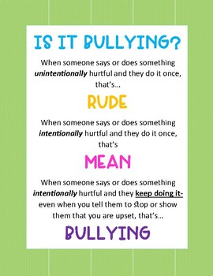

What you have already tried to do to stop it from
happening:

Who you have told about the bullying:

